

**LAB MANUAL of DATABASE**

**Submitted by: Basit Ali**

**Registration No: S23BSCS012**

**Section: ‘A’**

**Course: Introduction to Database**

**Department: Computer Science**

**Submitted to: Sir Irfan Ali**

**Date: 07 December, 2024**

**LAB ASSIGNMENT # 01**

Q#1: Creation of Database (own registration number)

**Query:**

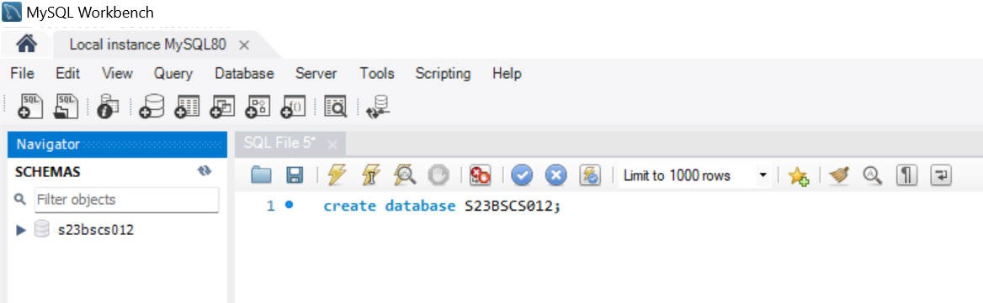

**Result:**

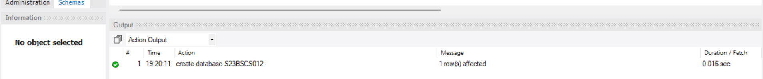

Q#2: Creation of Database (UOBS)

**Query:**

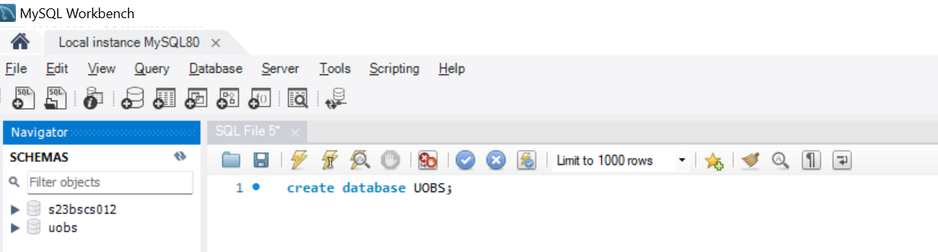

**Result:**

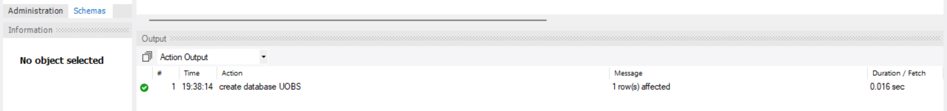

Q#3Create the following table is UOBS database with the following entities.

1. Campuses (id, c_name, c_location, c_incharge)

**Query:**

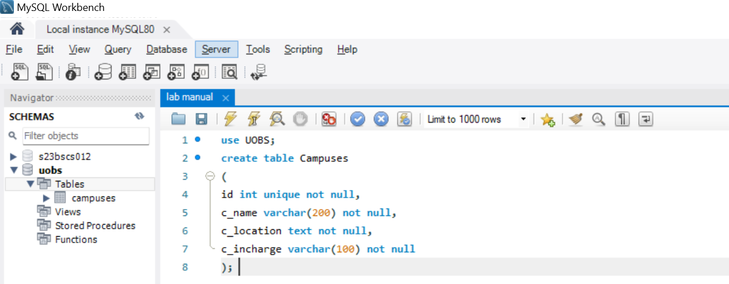

**Result:**

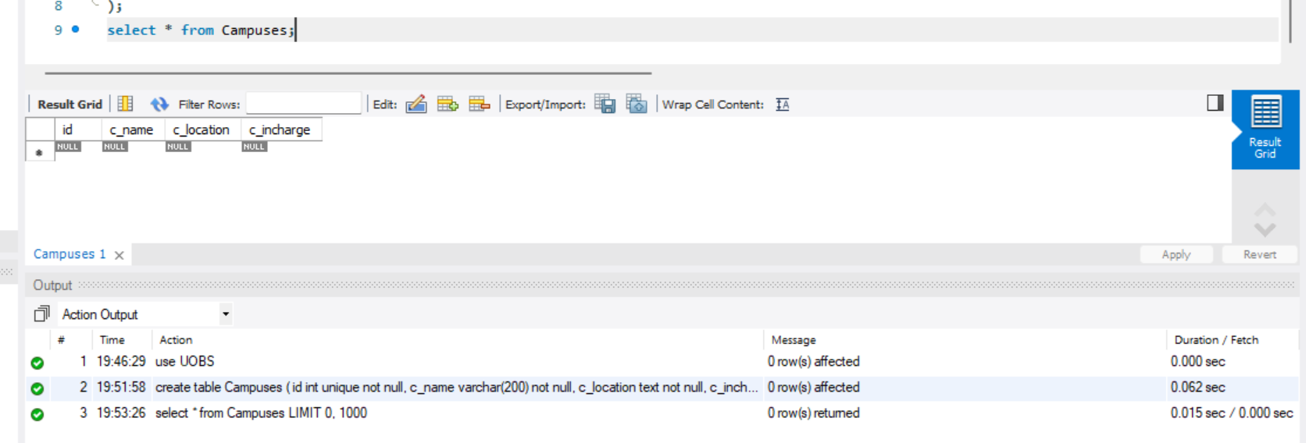

1. Department (d_name, d_location, d_hod)

**Query:**

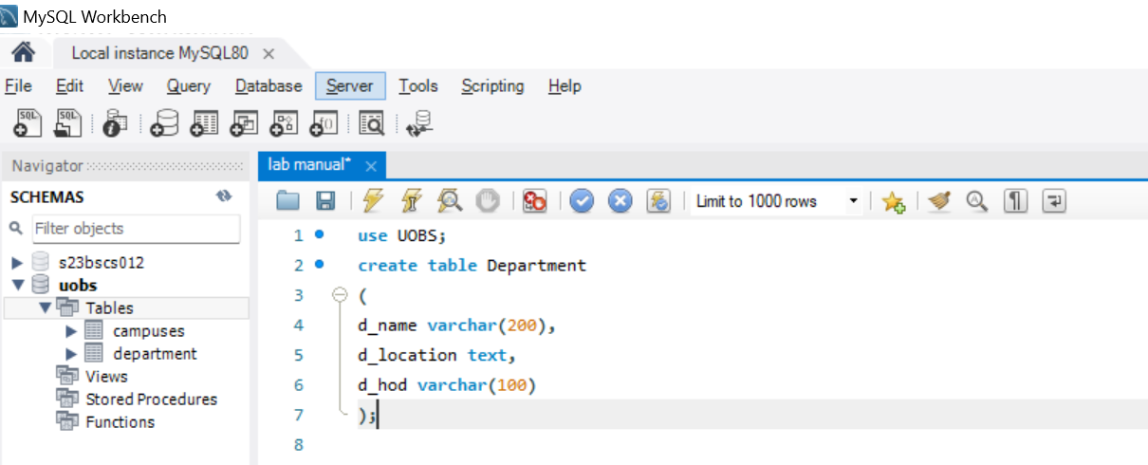

**Result:**

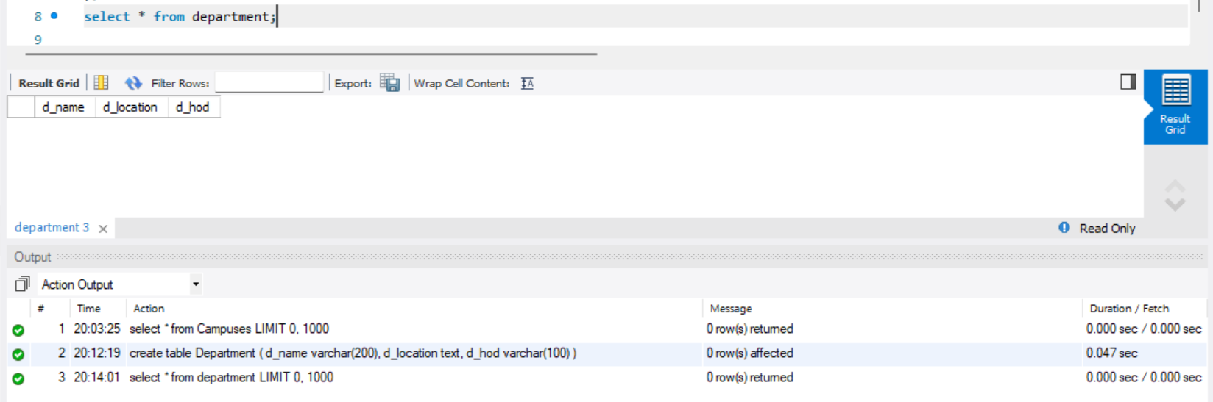

1. Students (std_id, std_name, std_email, std_address, std_department)

**Query:**

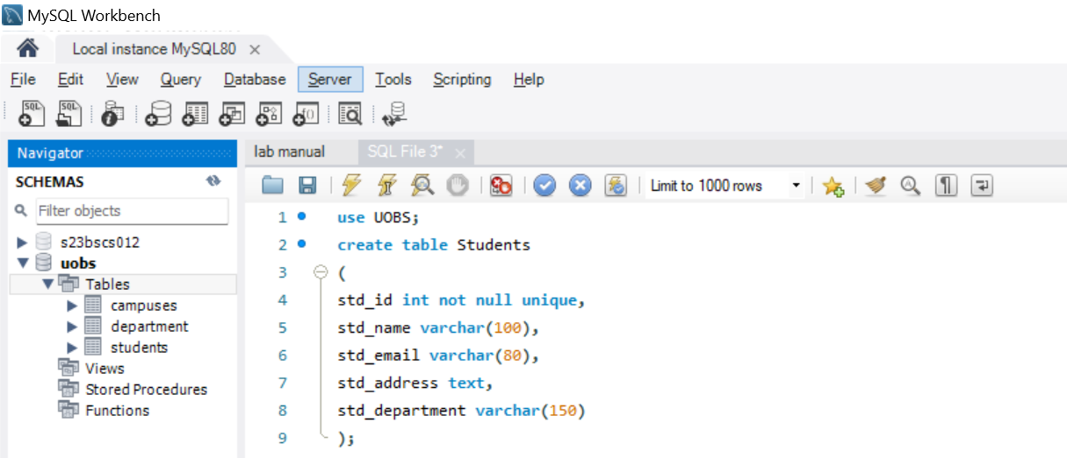

**Result:**

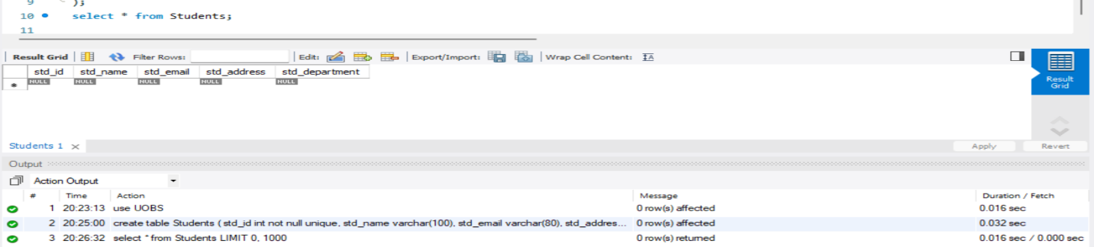

Q#4: Insertion of data into tables (Campuses, department, Students).

1. Campuses (4 names like main, anchan, city, sundus)

**Query:**

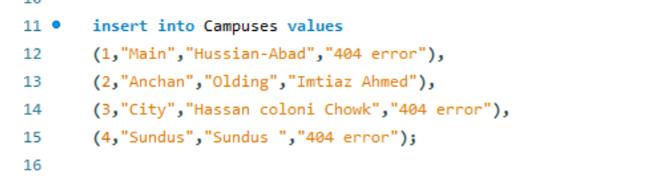

**Result:**

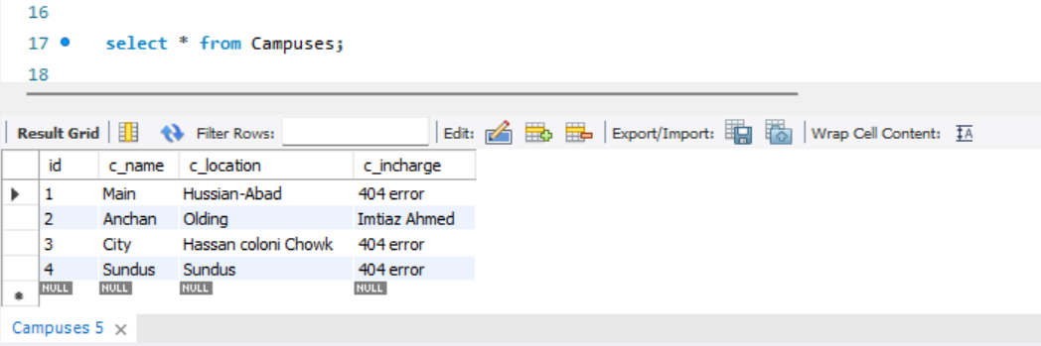

1. Department (mention minimum 5 departments)

**Query**:

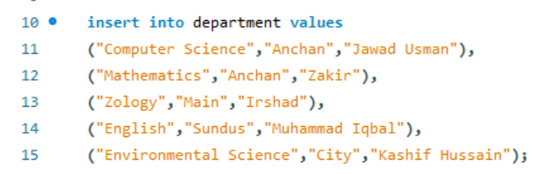

**Result:**

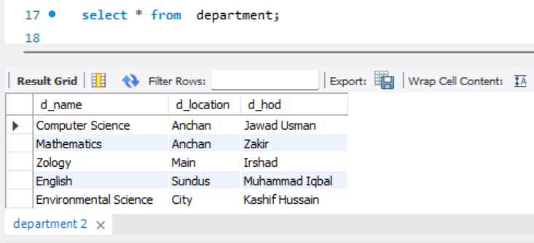

1. Students (write 1st student name as your own name and minimum 5 ids)

**Query:**

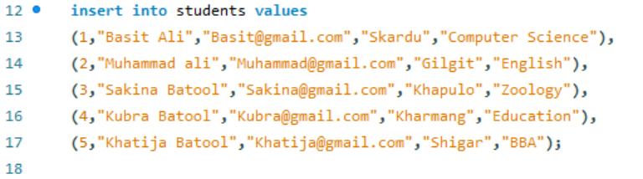

**Result:**

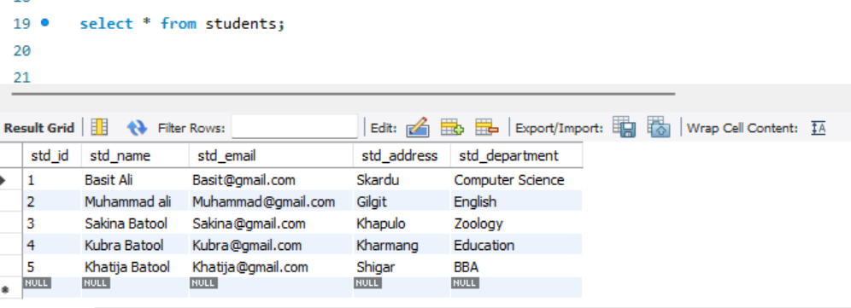

1. Delete Record id=5

**Query:**

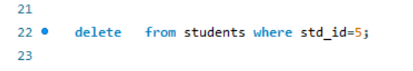

**Result:**

**Before:**



**After:**

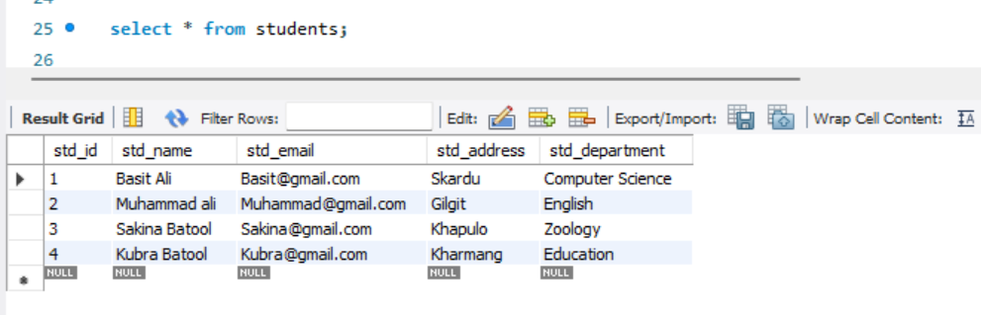

1. Update Record student id=3 with name Irfan

**Query:**

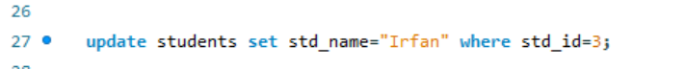

**Result:**

**Before:**



**After:**

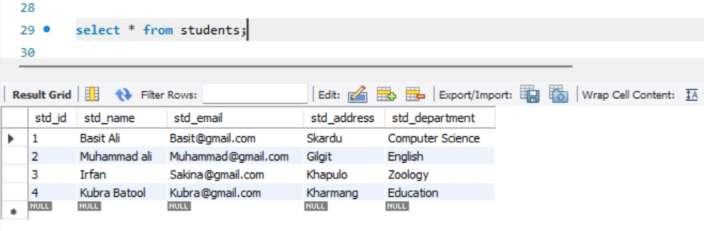

**LAB ASSIGNMENT # 02**

Q#1: Create of Database (student data) and create of table name (student_profile) in the database of (student data)

**Entities**

s_rollno, s_name, s_email, s_marks, s_department (minimum 5 rows having all department CS)

**Query:**

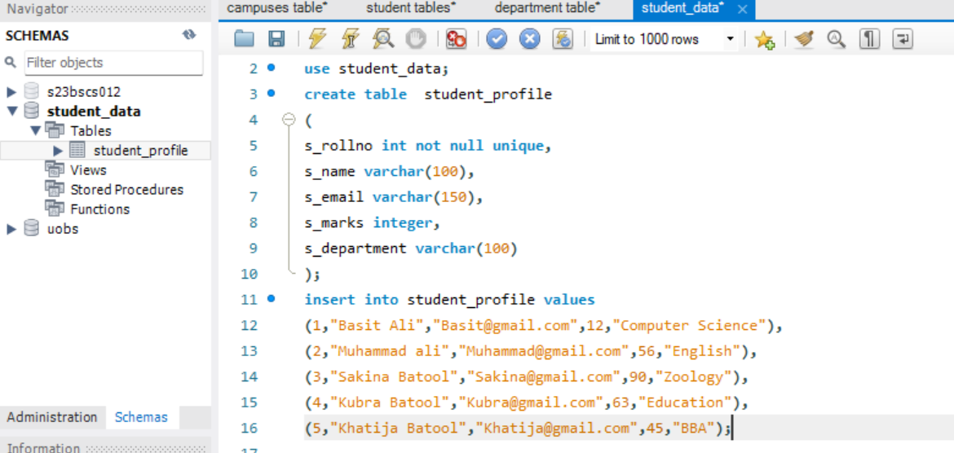

**Result:**

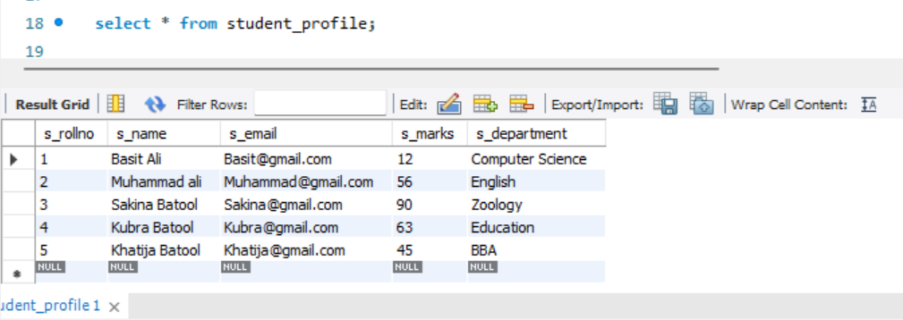

Solve the following queries also:

1. Insert three more records of students from “SE” department in the above table and then update the department of students having roll no. 1 and 2 as “AI” department.

**Query:**

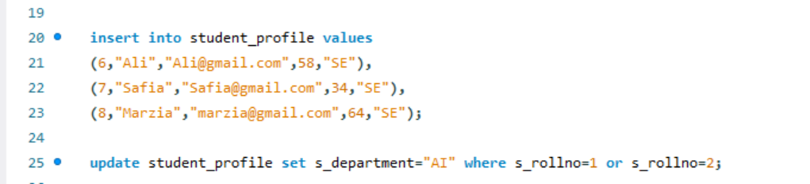

**Result:**

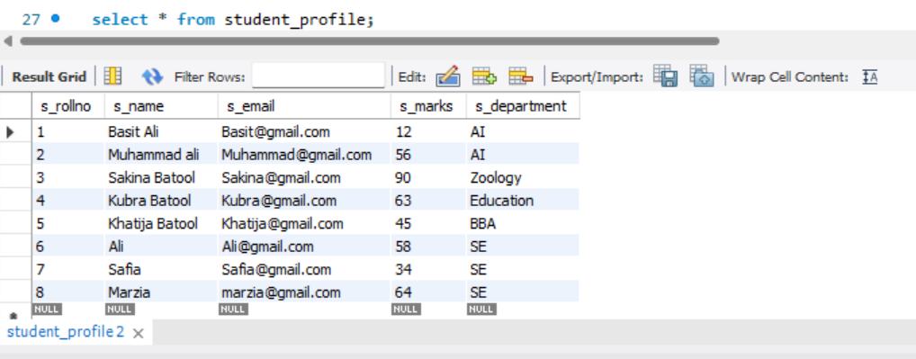

1. Find the email address of those students whose s_marks are below 55 or above 66.

**Query** and **Result:**

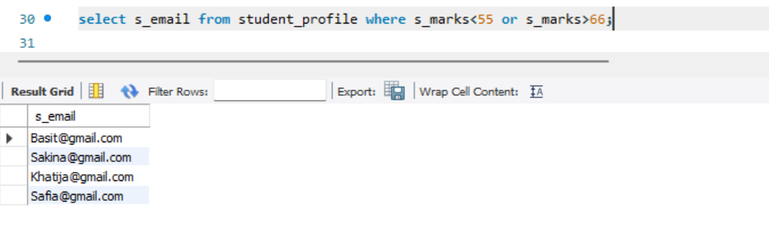

1. Display the column’s names of those “student_profil” table s_name as student name and s_marks as student marks. The marks should be in ascending order.

**Query** and **Result:**

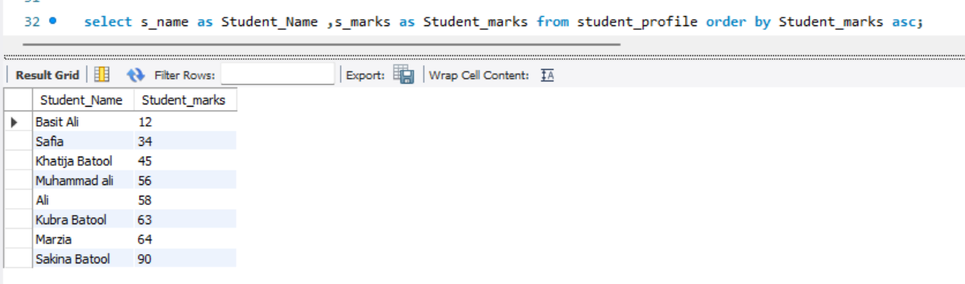

1. Create a table2 having two columns only “ename” and “ecity” to store a record of 8 employees. Use at least 5 distinct cities in the table.

**Query:**

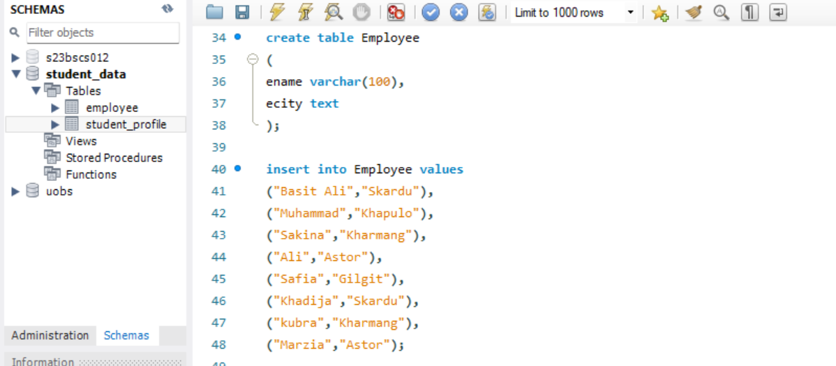

**Result:**

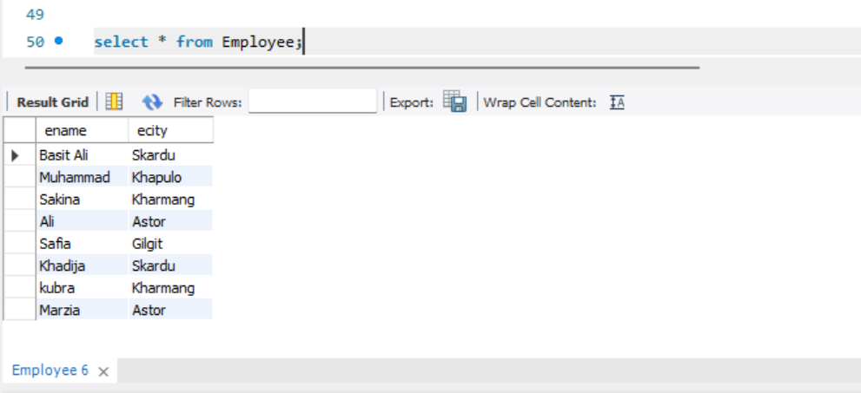

1. Use distinct command to show the list of different cities from employee.

**Query** and **Result:**

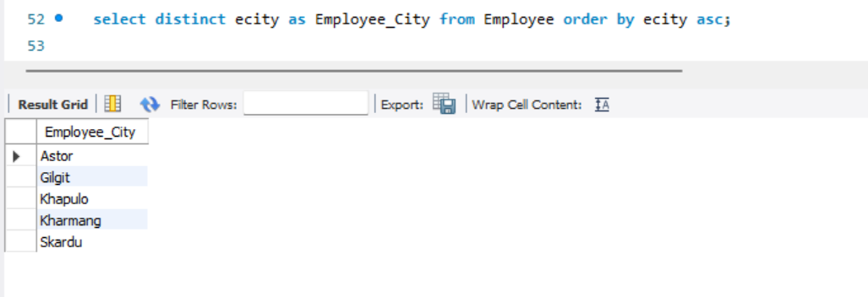

**LAB ASSIGNMENT # 03(Part-1)**

Q#1: Create a database for school.

**Query:**

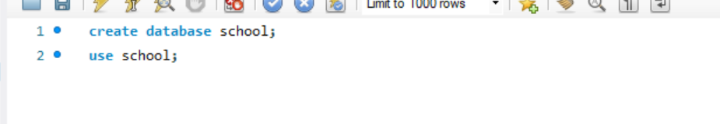

**Result:**

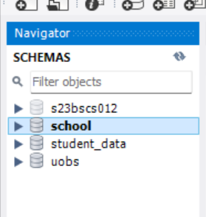

Q#2: Create a table(record) in school database and insert values.

**Query:**

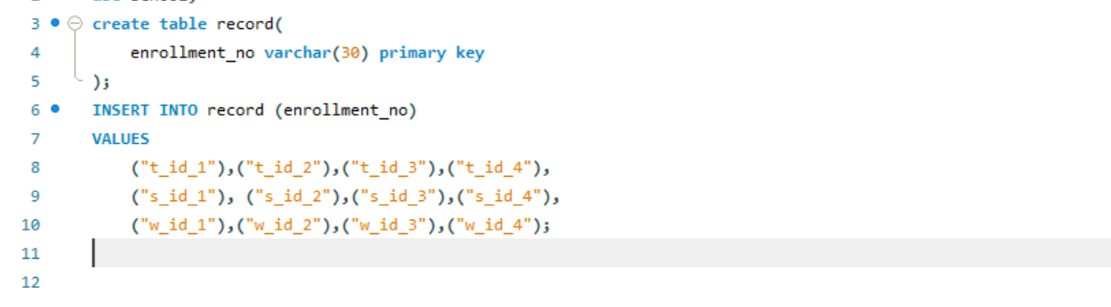

**Result:**

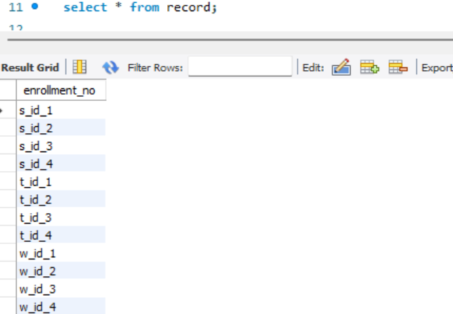

Q#3: Create student and its related tables (student, s_fees_detail, s_result_detail, s_attendance_detail), insert data into tables and show their result.

1. Create student and its related tables.

**Queries:**

1. Student:

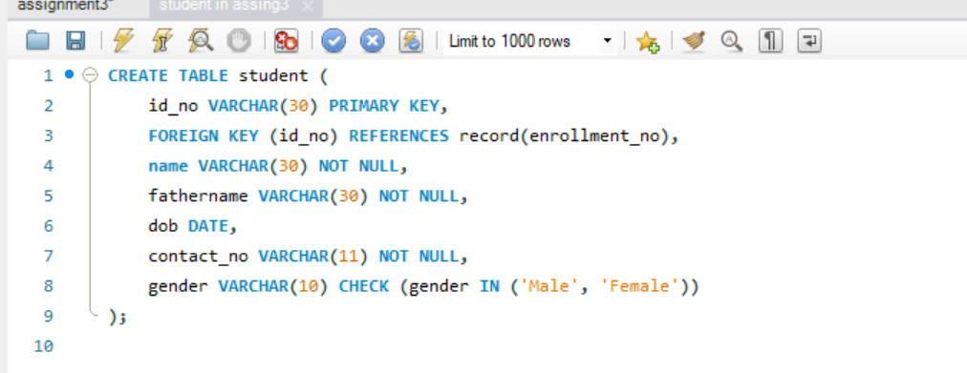

1. Student Fees Detail:

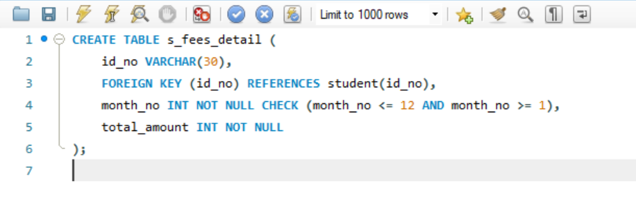

1. Student Attendance Detail:

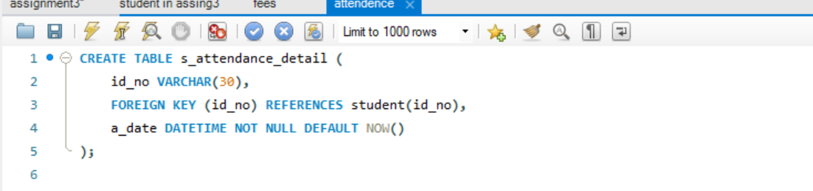

1. Student Result Detail:

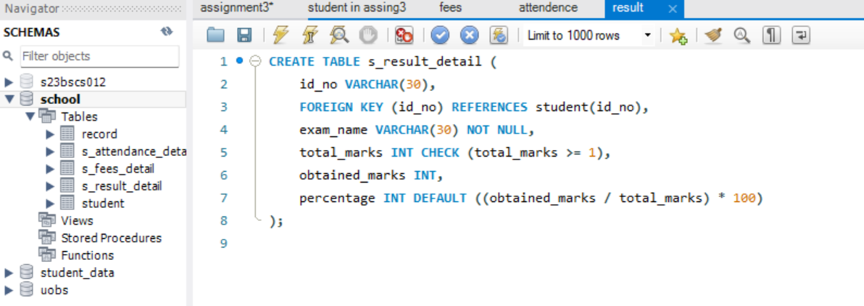

1. Insert data into student and its related tables

**Queries:**

1. Student:

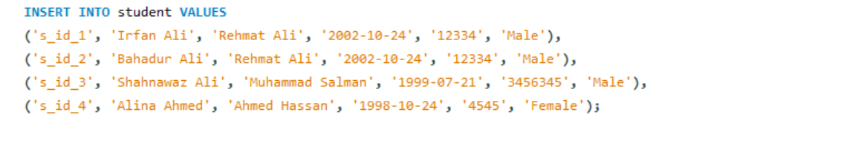

1. Student Fees Detail:

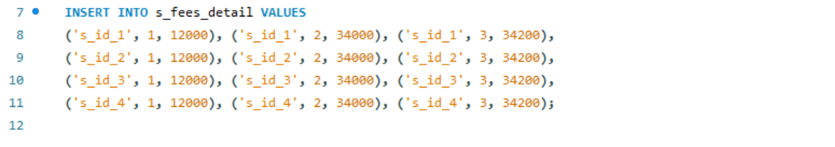

1. Student Attendance Detail:



1. Student Result Detail:

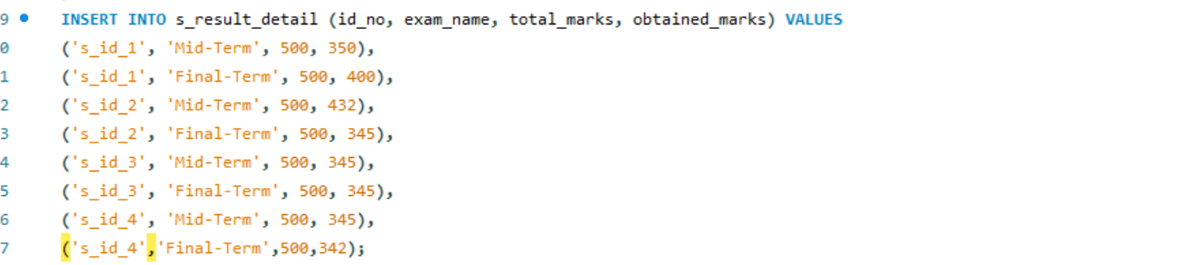

1. Show the result of student and its related table.

**Result:**

1. Student:

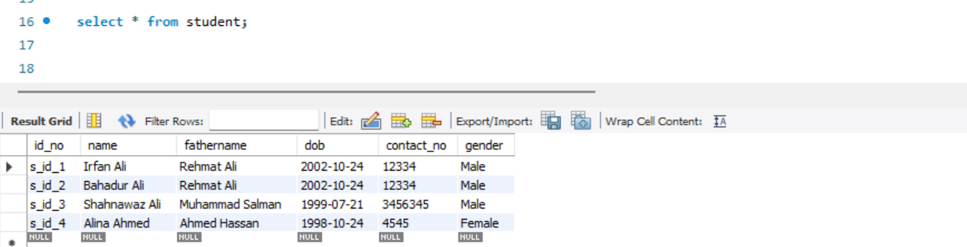

1. Student Fees Detail:

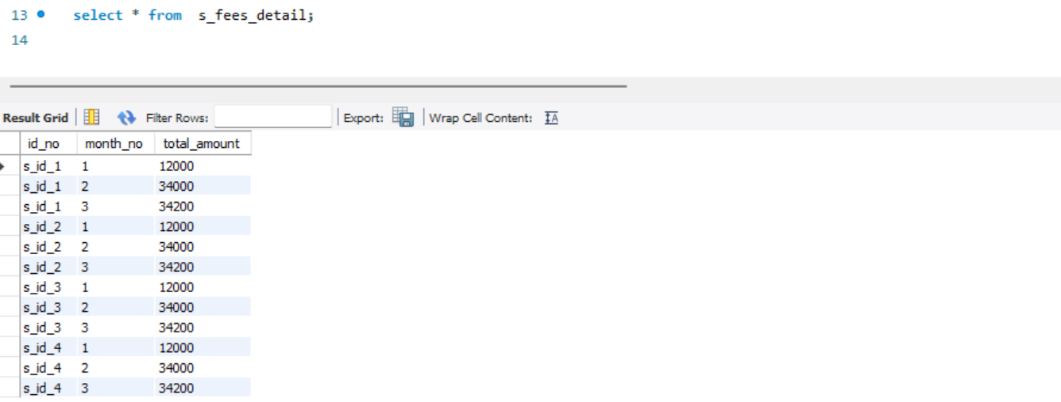

1. Student Attendance Detail:

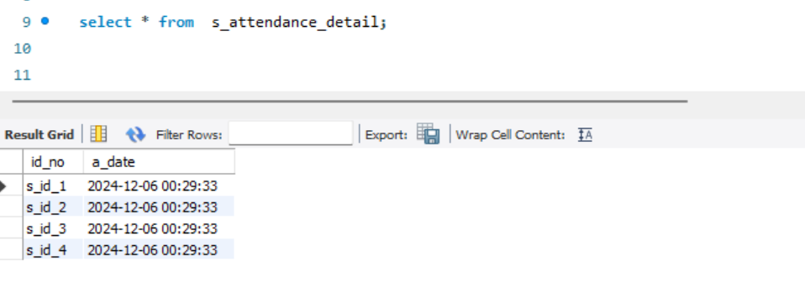

1. Student Result Detail:

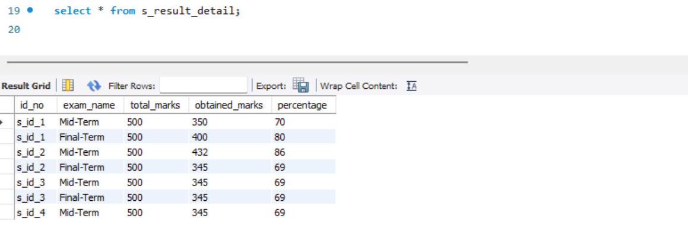

Q#4: Create teacher and its related tables (teacher, t_salary_detail, t_attendance_detail), insert data into table and show their result.

1. Teacher tables

**Queries:**

1. Teacher

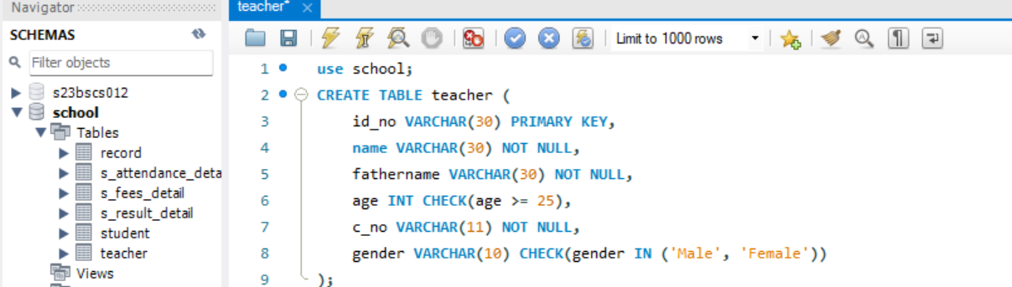

1. Teacher Salary Detail

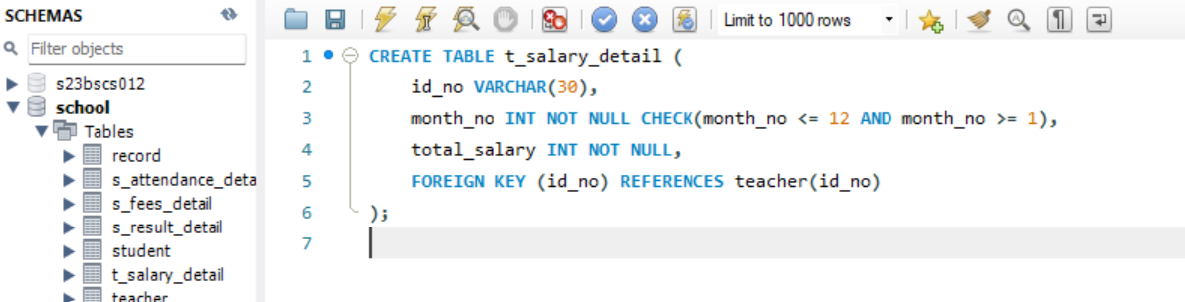

1. Teacher Attendance Detail

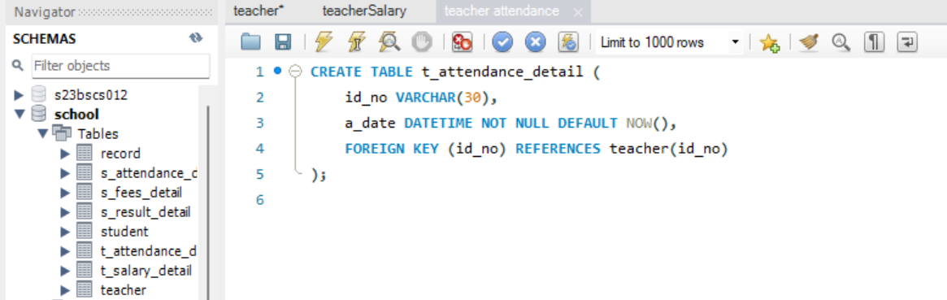

1. Insert data into teacher and its related tables.

**Queries:**

1. Insert data into teacher table

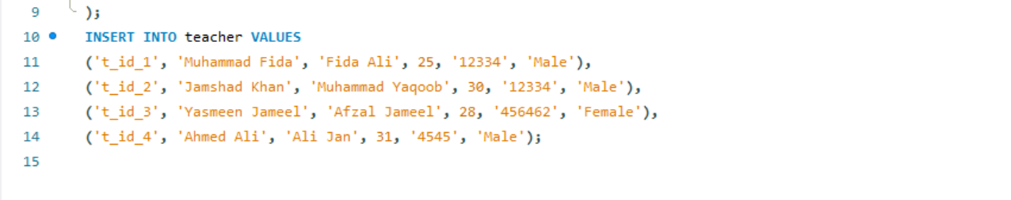

1. Insert data into teacher salary table

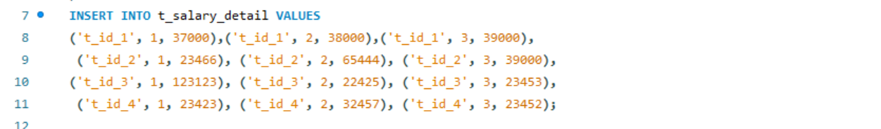

1. Insert data into teacher attendance table



1. Show the result of teacher and its related tables.

**Result:**

1. Result of teacher table.

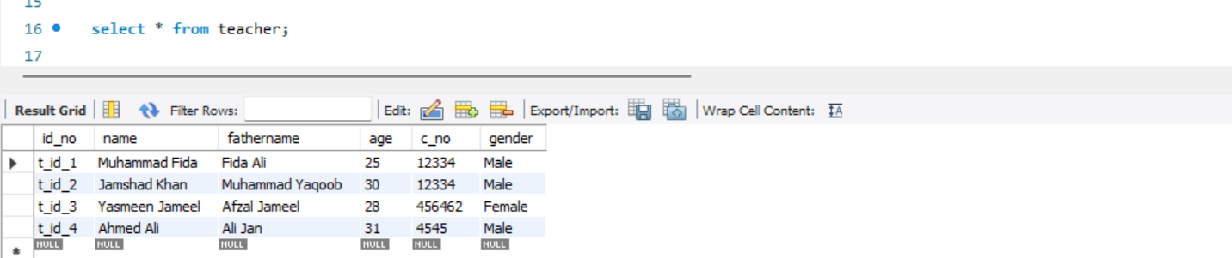

1. Result of teacher attendance table.

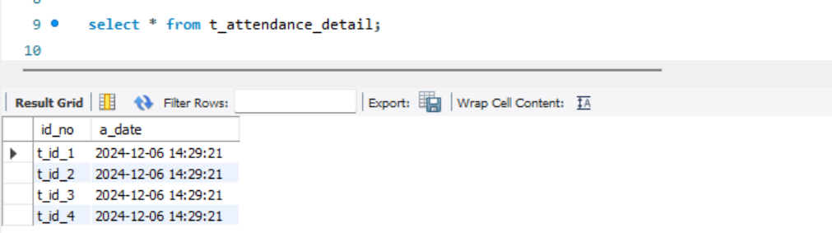

1. Result of teacher salary table.

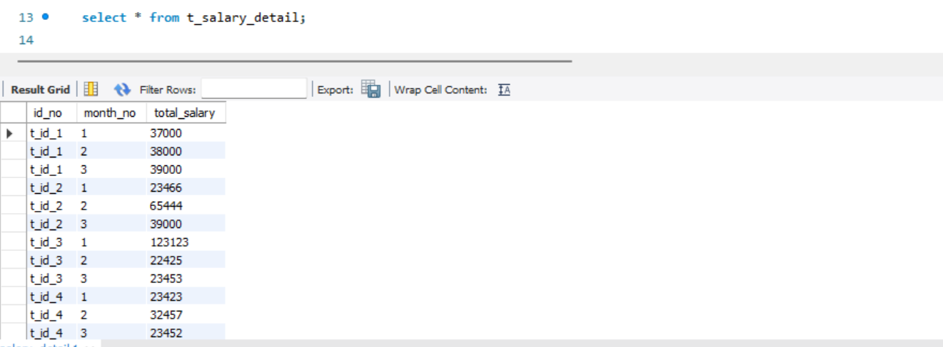

Q#4: Create a worker and its related table (worker, w_salary_detail, w_attendance_detail), insert data into tables and show their result.

1. Worker tables

**Queries:**

1. Table of worker

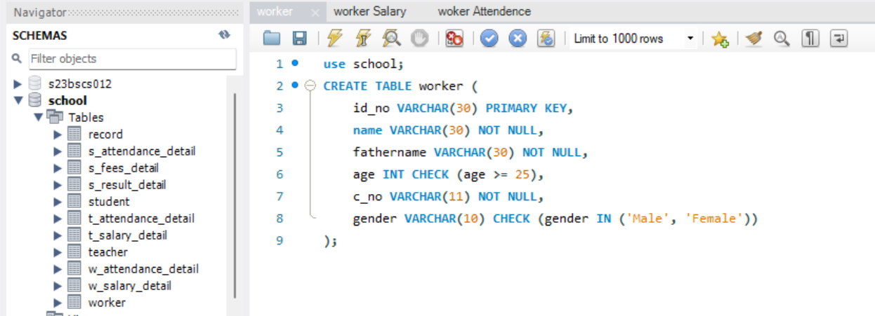

1. Table of worker salary

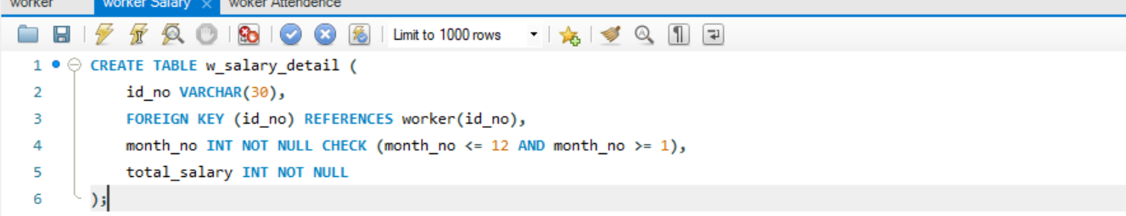

1. Table of worker Attendance

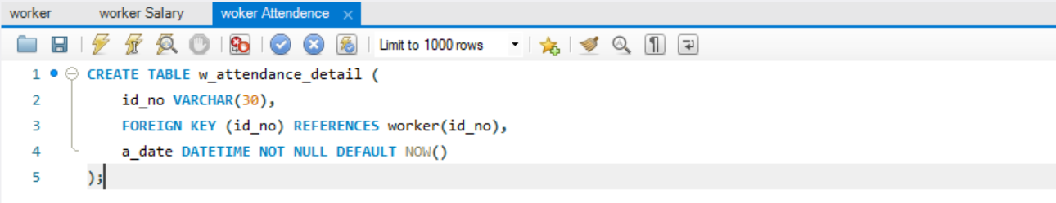

1. Insert data into worker and its related table.

**Queries:**

1. Insert data into worker table.

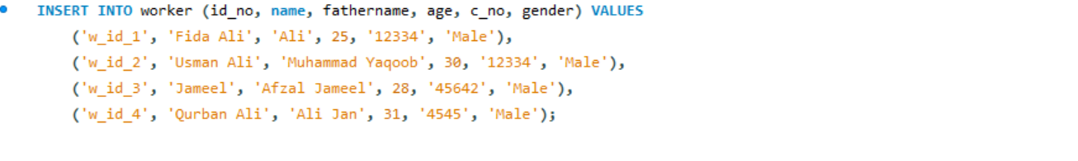

1. Insert data into worker salary table.

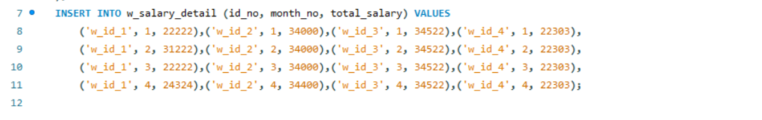

1. Insert data into worker attendance table.



1. Show result of worker and its related tables

**Result:**

1. Result of worker table

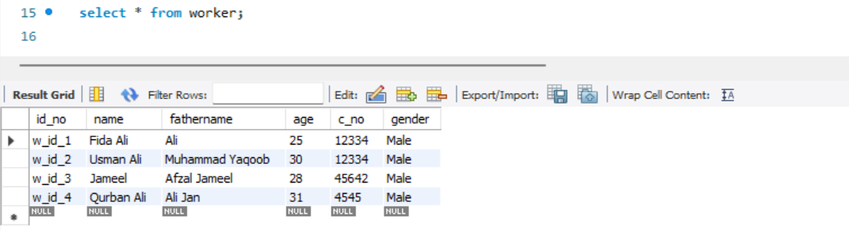

1. Result of worker salary table

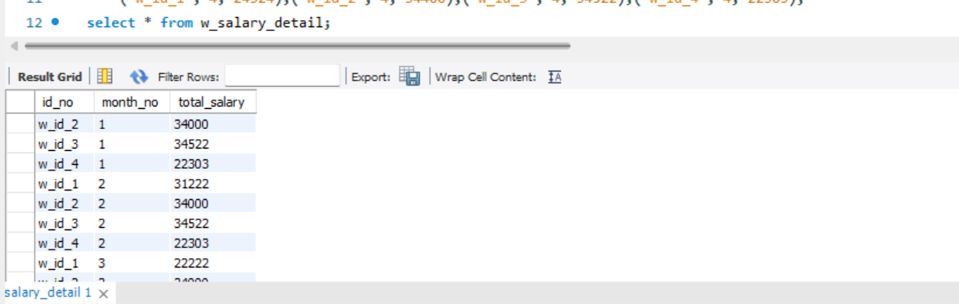

1. Result of worker Attendance table

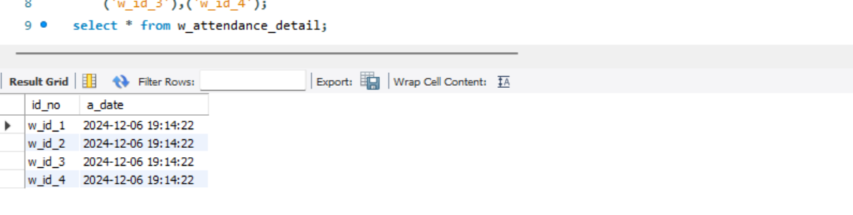

**LAB ASSIGNMENT # 03(Part-2)**

Q#1: Create a database for university

**Query and Result:**

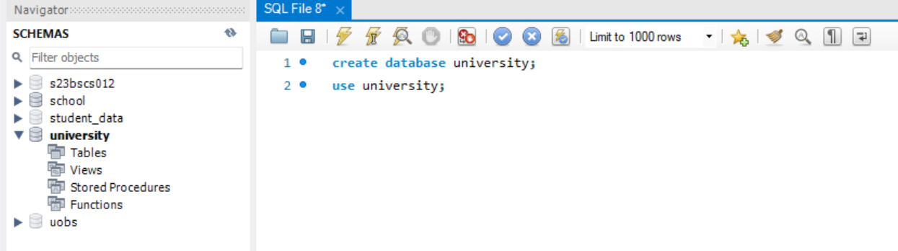

1. Create a table for the student and insert data.

**Queries:**

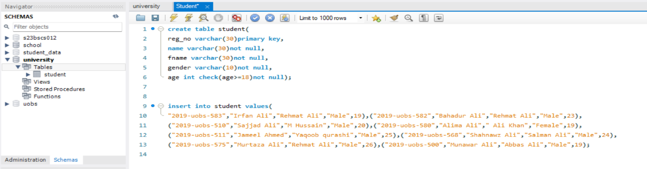

**Result:**

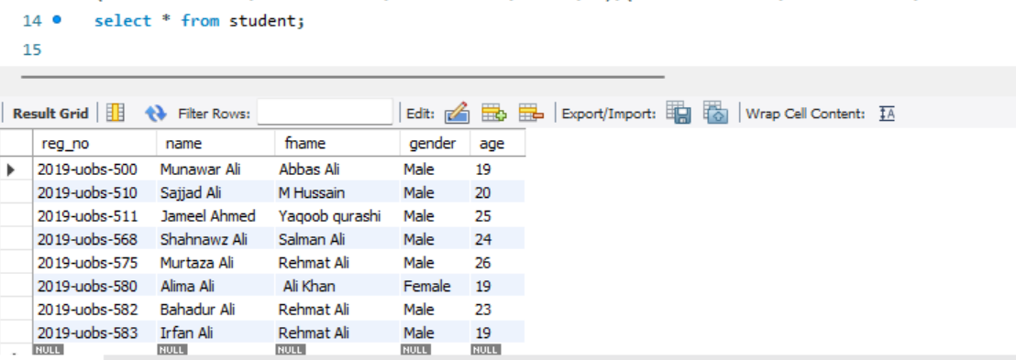

1. Create semester (1,2,3,4,5,6,7,8, and final year degree) table and insert data into each table
2. Semester-1

**Queries:**

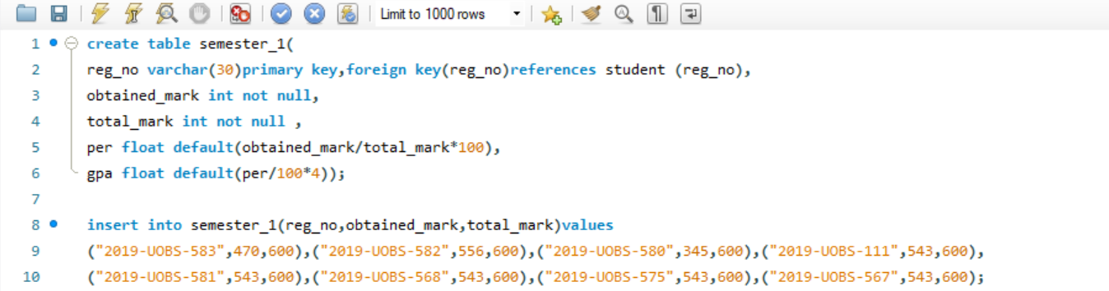

**Result:**

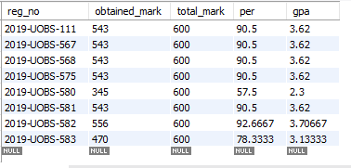

1. Semester-2

**Queries:**

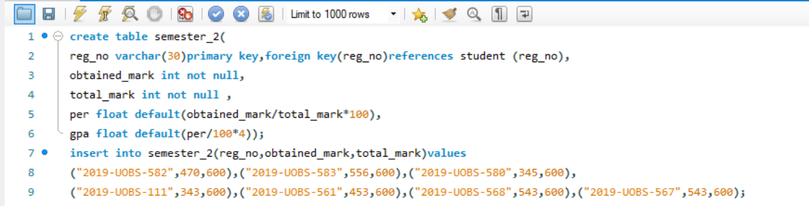

**Result:**

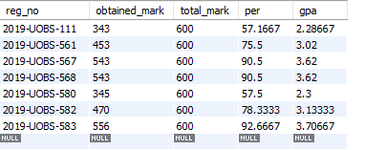

1. Semester-3

**Queries:**

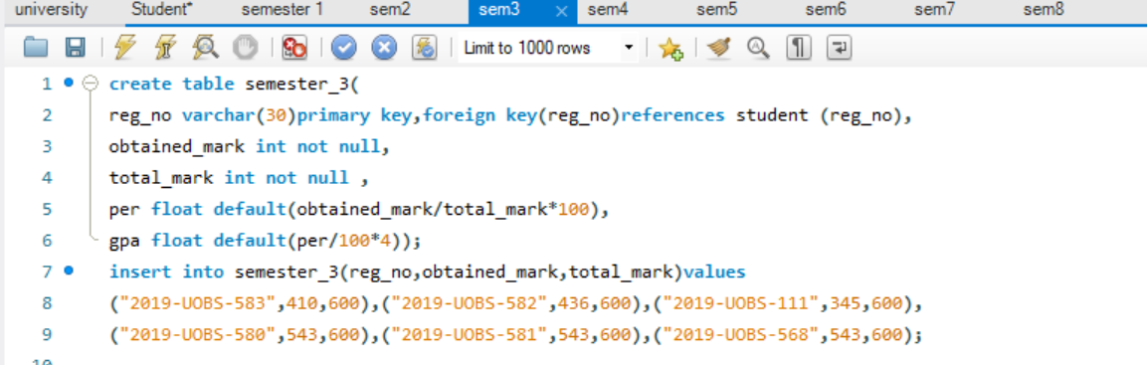

**Result:**

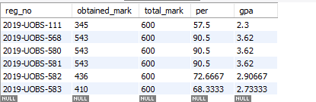

1. Semester-4

**Queries:**

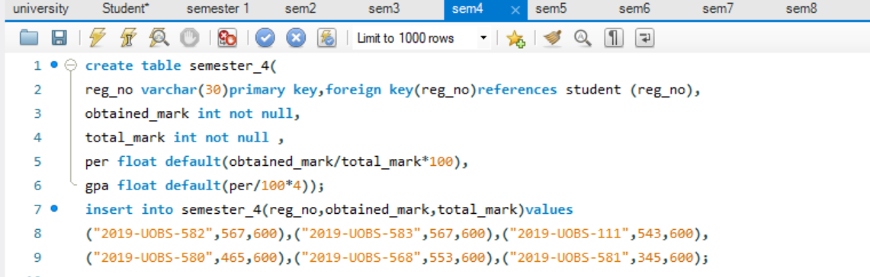

**Result:**

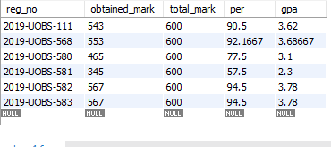

1. Semester-5

**Queries:**

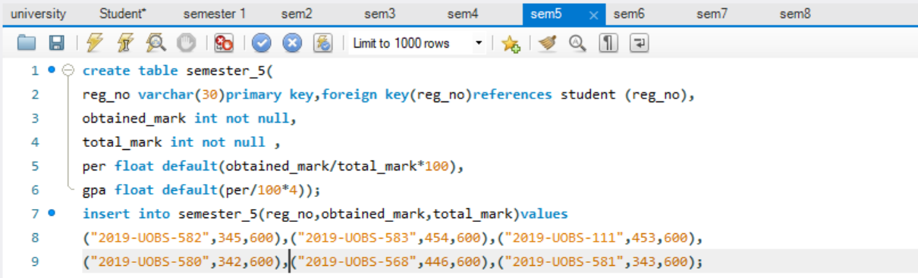

**Result:**

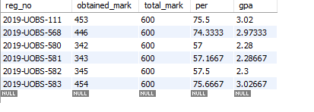

1. Semester-6

**Queries:**

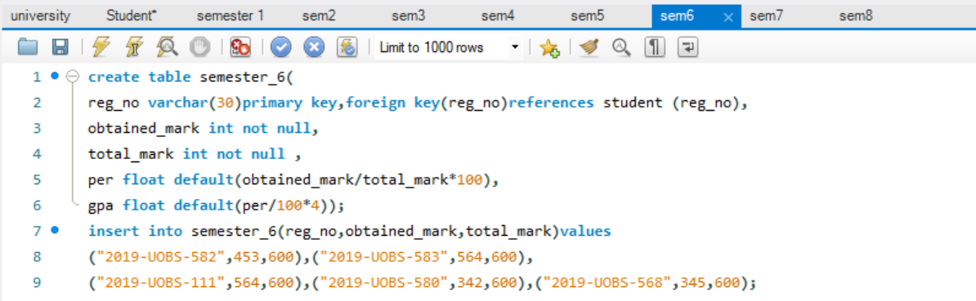

**Result:**



1. Semester-7

**Queries:**

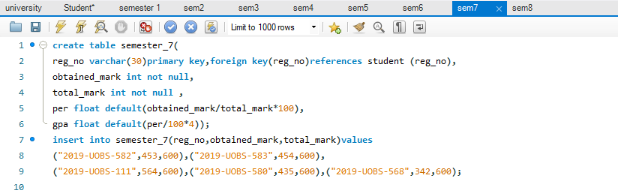

**Result:**

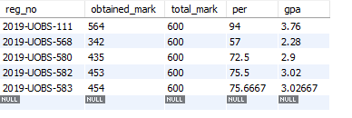

1. Semester-8

**Queries:**

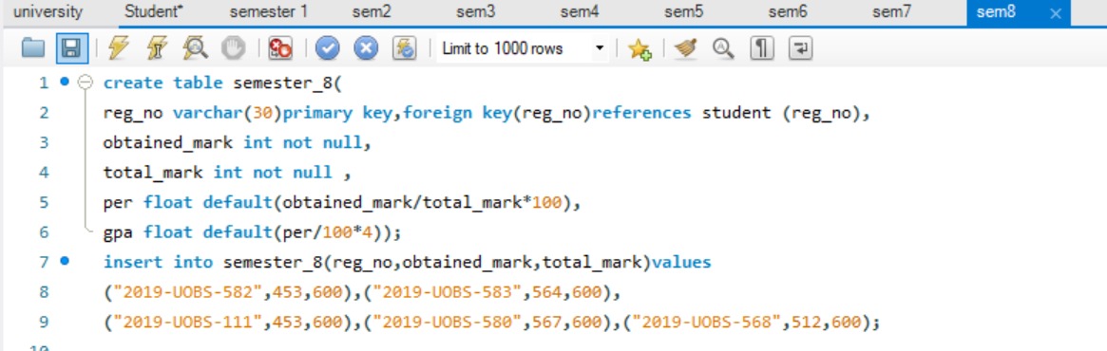

**Result:**

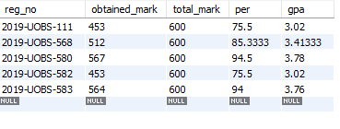

1. Final year Degree

**Queries:**

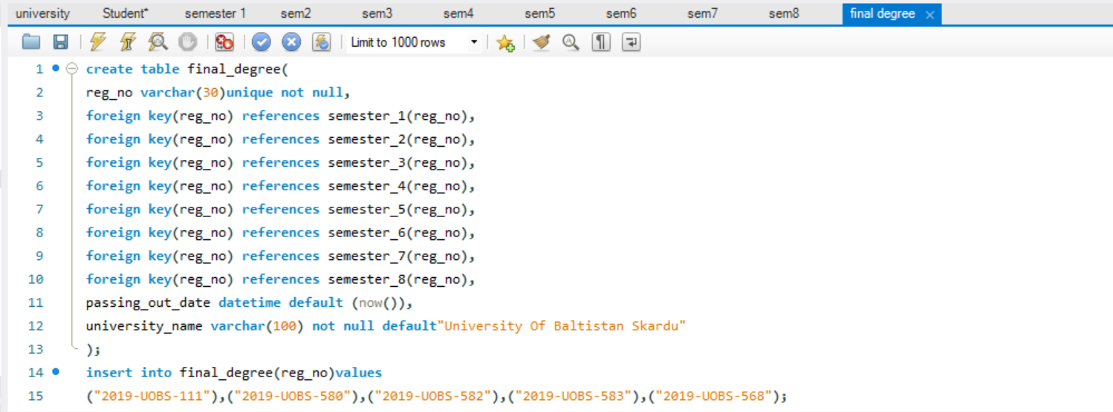

**Result:**

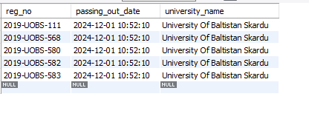

**LAB ASSIGNMENT # 04**

Q#1: Repeat the example 1 and 2 of lab 5.

**Queries:**

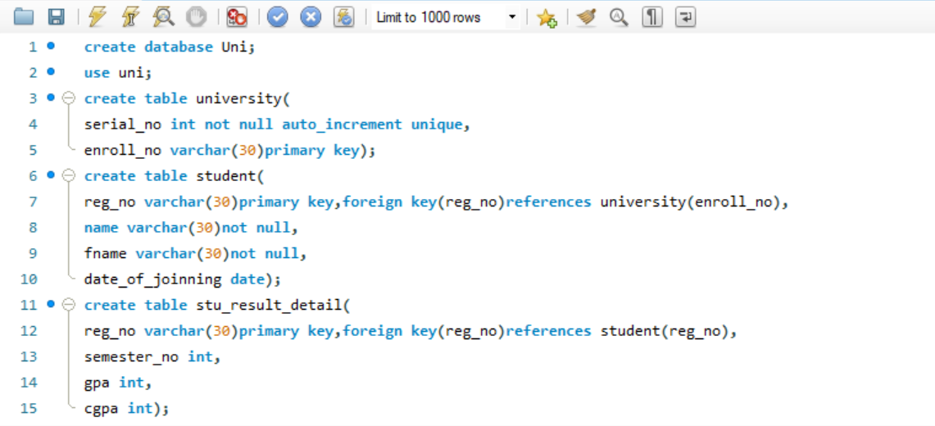

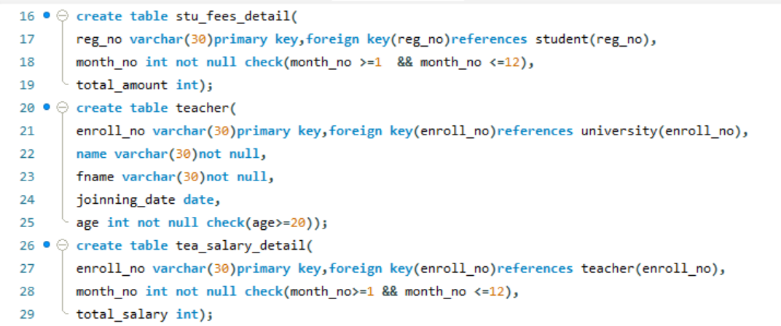

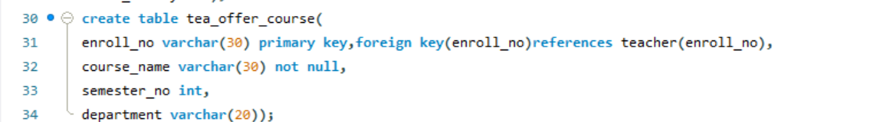

**Result:**

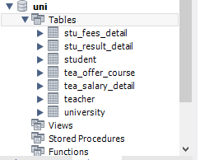

Q#2: Create a database “example-2” which the following tables (help, student, subject).

**Queries:**

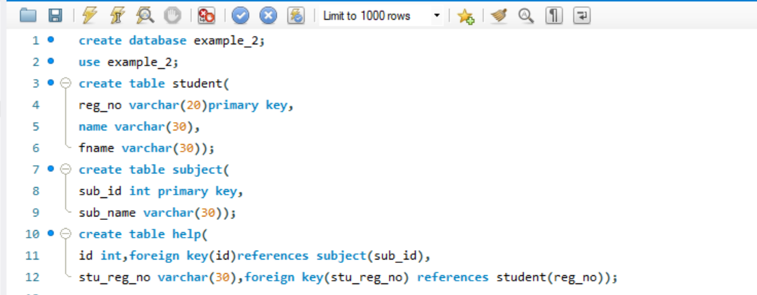

**Result:**

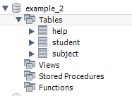

***The End***